**Lab: Regression**

1) Download the voice data folder from Kaggle website by registering your name.

2) Drag the operator “Read CSV” into the process window and load the data file “voice.csv”. Set the label variable data type as “binominal”.

3) “Set Role” operator is set with an attribute name and target role as mentioned below

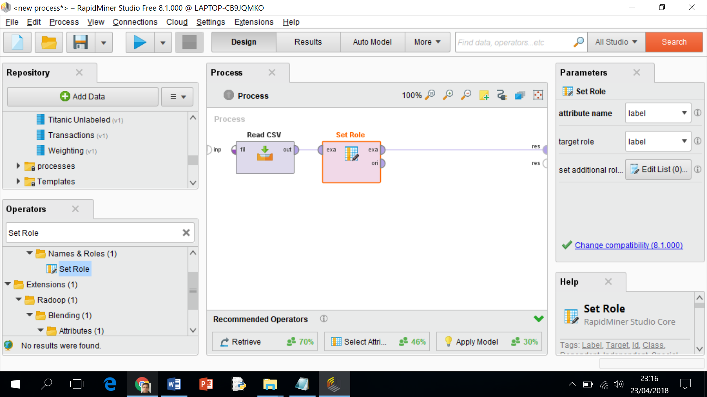

4) Select the “Split Data” operator and split the data into training set as mentioned below

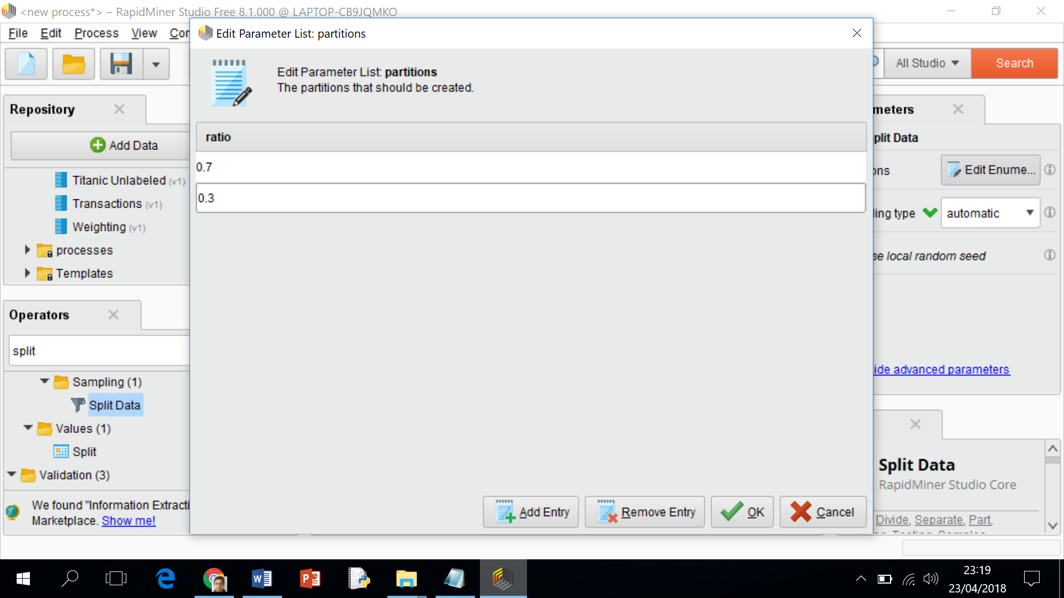

5) The following operators are considered as shown below

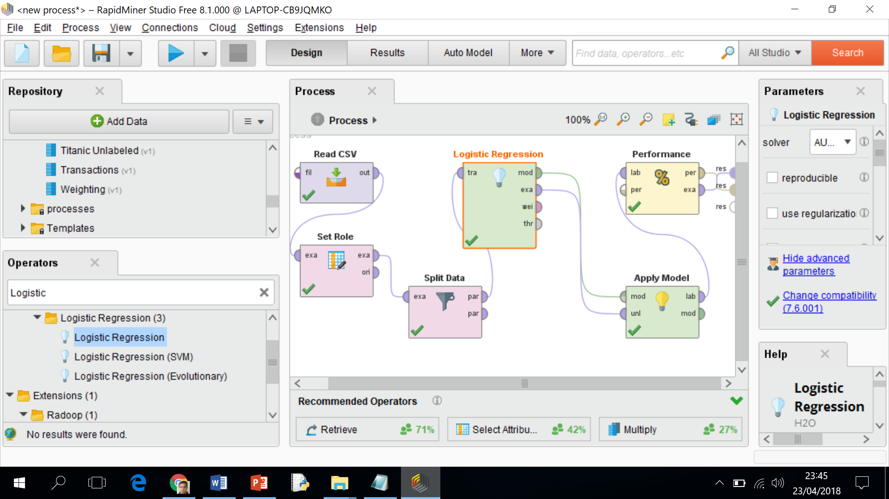

6) Execute the Rpidminer model to find the outcome as mentioned below

